**Docker Task**

**Task Description:**

Install docker on EC2 and explore the docker commands (docker images, containers, volumes, network)

Answer:

Steps:

1. Create new Ec2

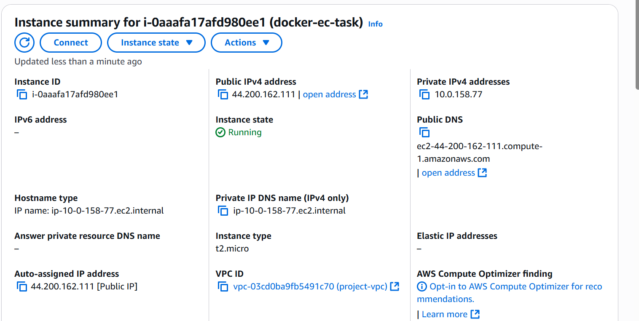

1. Install docker

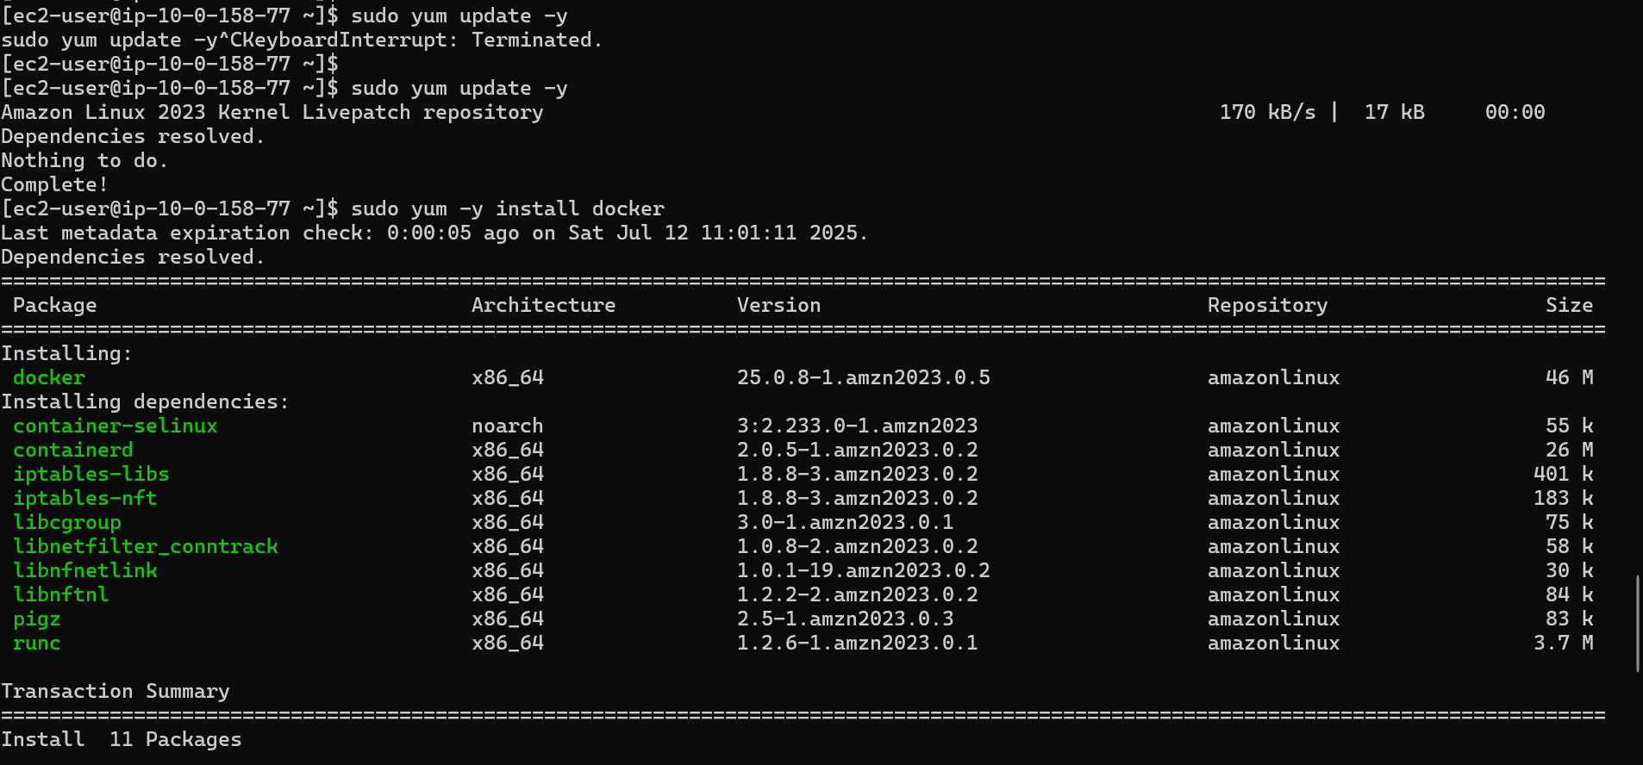



1. Exploring Docker images

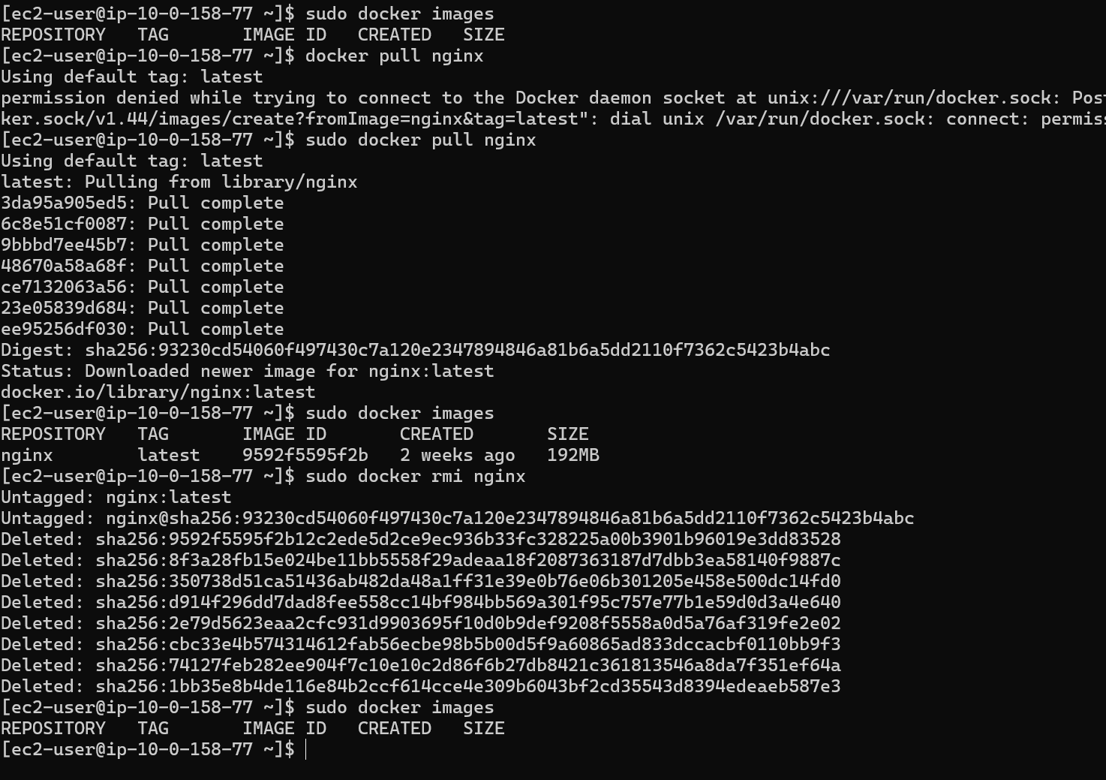

1. Exploring docker containers

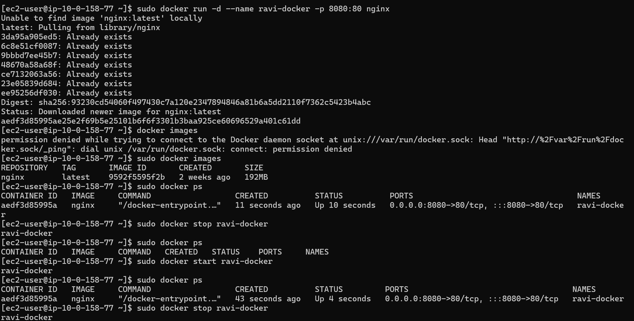



1. Exploring docker volumes

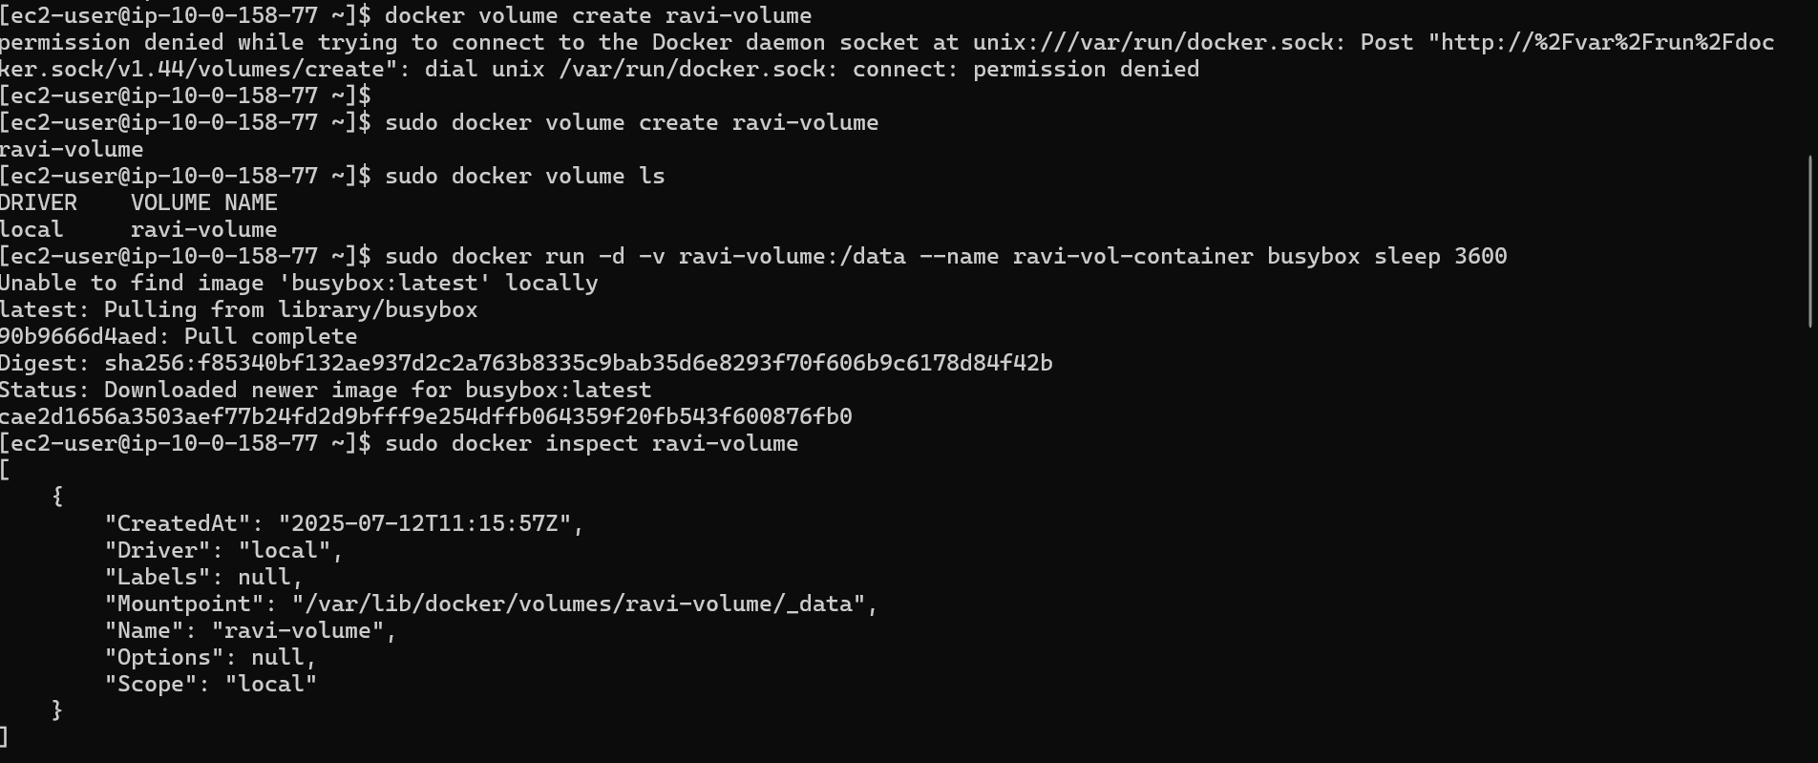

1. exploring docker networks

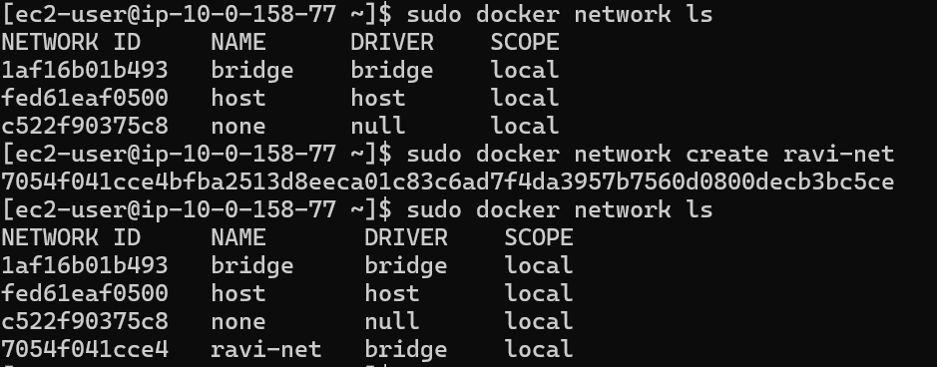

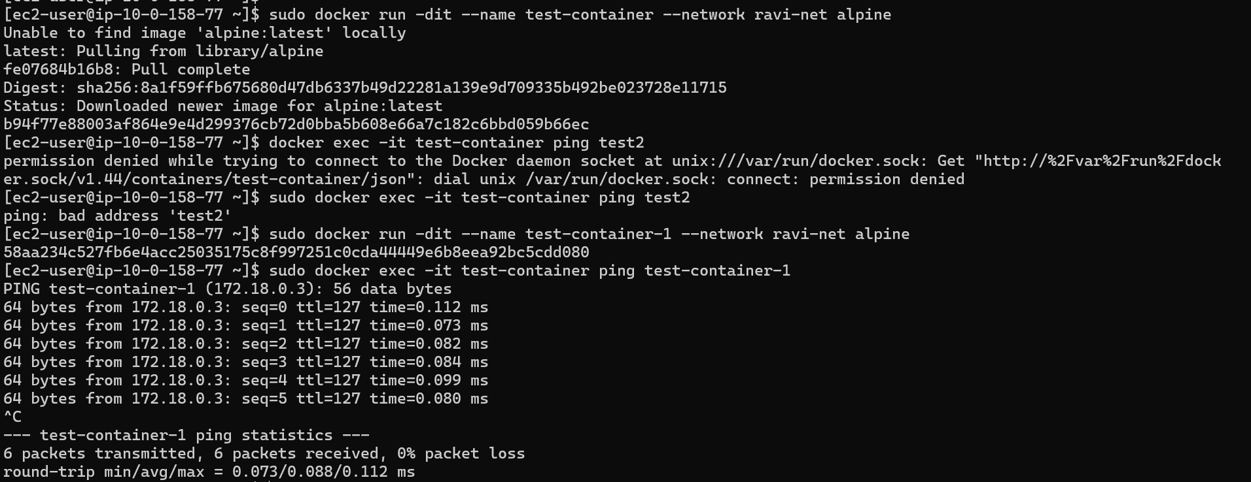

1. Removing containers, volumes and networks

